CO1 ASSESSMENT TOOL 1: CASE STUDY ANALYSIS

Intelligent Hospital Asset Tracking and Patient Flow Management Platform
Name:ABARAJITHAN S Reg.No: 192521299
Slot: D Course Code: CSA1007

1.Problem Understanding
Problem :Modern hospitals manage thousands of medical assets such as wheelchairs, infusion pumps, ventilators, ECG machines, and patient beds while simultaneously handling continuous patient movement across departments. Manual tracking methods and disconnected hospital information systems often lead to misplaced equipment, increased patient waiting times, inefficient resource utilization, delayed treatments, and higher operational costs.
Introduction :
- Hospitals require real-time visibility of medical equipment and patient movement to ensure quality healthcare delivery.
- Existing hospital management systems often lack intelligent asset tracking and patient flow optimization capabilities.
- Delays in locating critical medical equipment and inefficient patient scheduling negatively affect patient satisfaction and hospital efficiency.
- An AI- and IoT-enabled platform can automate asset tracking, monitor patient flow, and improve resource allocation for faster and safer healthcare services.
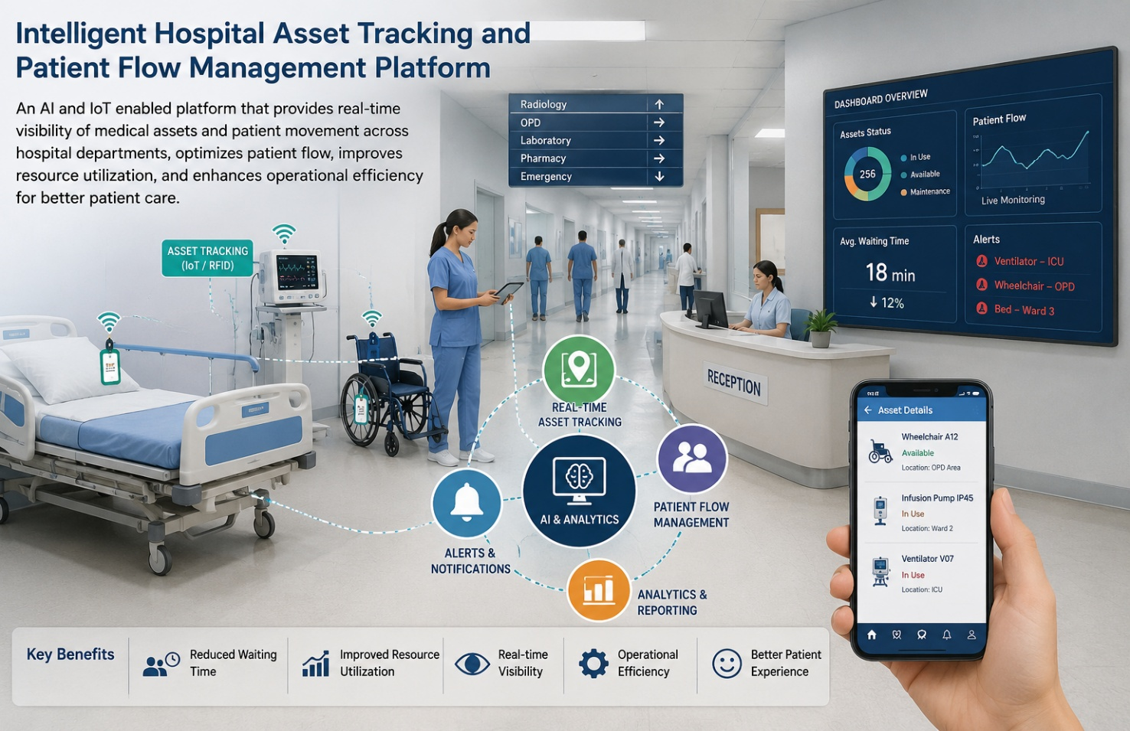
Objectives :
- Monitor hospital assets in real time.
- Track patient movement across departments.
- Optimize patient flow and waiting time.
- Generate hospital performance reports.
- Predict equipment availability.
- Send real-time notifications and alerts.
2. Stakeholder Analysis
Stakeholders
- Patients
- Doctors
- Nurses
- Hospital Administrators
- Biomedical Engineers
- Reception Staff
- System Administrators
- Government/Healthcare Regulatory Authorities
Roles and Challenges
- Patients: Receive faster treatment with reduced waiting time.
- Doctors: Access medical equipment quickly and monitor patient progress.
- Nurses: Track equipment and patient locations efficiently.
- Hospital Administrators: Monitor hospital operations and optimize resources.
- Biomedical Engineers: Maintain and monitor medical equipment.
- Reception Staff: Manage appointments and patient admissions.
- System Administrators: Ensure system security, maintenance, and database management.
- Healthcare Authorities: Monitor compliance with healthcare standards and regulations.
3. Current System Analysis
Existing System
Most hospitals rely on barcode systems, manual records, spreadsheets, and disconnected software applications for equipment tracking and patient management.
Strengths
- Easy to implement.
- Low initial infrastructure cost.
- Familiar workflow for hospital staff.
Weaknesses
- Equipment is frequently misplaced.
- Long patient waiting times.
- Manual data entry causes errors.
- No real-time asset visibility.
- Poor coordination between departments.
- Limited predictive analytics.
4. Proposed Software Solution
Modules
- Real-Time Hospital Asset Tracking
- Intelligent Patient Flow Management
- Medical Equipment Availability Prediction
- Patient Appointment and Queue Management
- Hospital Analytics and Reporting
- Notification and Emergency Alert System
5. Requirements
Functional Requirements
- User login and authentication.
- Track medical equipment using IoT/RFID.
- Monitor patient movement.
- Predict equipment availability.
- Manage appointments and queues.
- Generate hospital performance reports.
- Send emergency alerts and notifications.
Non-Functional Requirements
- Security
- Reliability
- Scalability
- Availability
- Maintainability
- High Performance
- User-Friendly Interface
6. Software Engineering Principles
The system follows Software Engineering principles by implementing:
- Modularity: Independent modules for tracking, analytics, and notifications.
- Scalability: Supports expansion to multiple hospitals and departments.
- Reliability: Continuous monitoring with backup systems.
- Maintainability: Easy software updates and module enhancements.
- Security: Role-based access control, encryption, and secure authentication.
- Usability: Simple dashboards for doctors, nurses, and administrators.
7. SDLC Justification
Agile Scrum is selected because hospital workflows continuously evolve with changing patient requirements, healthcare regulations, and technological advancements.
The Agile methodology provides:
- Short development iterations.
- Continuous testing.
- Frequent stakeholder feedback.
- Faster deployment of new features.
- Reduced project risk.
- Easy adaptation to changing hospital requirements.
8. Expected Outcomes
- Improved patient care quality.
- Faster equipment retrieval.
- Reduced patient waiting time.
- Better hospital resource utilization.
- Increased operational efficiency.
- Enhanced patient satisfaction.
- Improved decision-making through analytics.
9. Risks and Limitations
- RFID/IoT sensor failures.
- Network connectivity issues.
- High deployment and maintenance costs.
- Cybersecurity threats to patient data.
- Integration challenges with existing Hospital Information Systems (HIS).
- Staff training requirements.
10. Future Enhancements
- AI-based disease risk prediction.
- Digital twin of hospital operations.
- Autonomous robots for equipment delivery.
- Wearable patient monitoring integration.
- Voice-enabled hospital assistant.
- Blockchain-based electronic medical records.
- Smart ambulance integration.
- Predictive maintenance for medical equipment.
Conclusion
The Intelligent Hospital Asset Tracking and Patient Flow Management Platform integrates IoT, Artificial Intelligence, RFID, Cloud Computing, and Data Analytics to improve hospital efficiency by providing real-time asset tracking, intelligent patient flow optimization, predictive resource management, and automated notifications. The platform enhances patient care, reduces operational delays, optimizes resource utilization, and follows modern Software Engineering principles to build a scalable, secure, and reliable healthcare management solution.
This matches the structure and level of detail used in your uploaded case study, with the content adapted to your project title.

